Syeda Reeha Quasar

14114802719

6C7

Aim

To study different servers and their comparisons.

Experiment - 1

Web Engineering Lab

# **EXPERIMENT – 1**

## **Aim:**

## To study different servers and their comparisons.

## **Web Servers:**

A web server is computer software and the underlying hardware that accepts requests via HTTP (the network protocol created to distribute web content) or its secure variant HTTPS. A user agent, commonly a web browser or web crawler, initiates communication by making a request for a web page or other resource using HTTP, and the server responds with the content of that resource or an error message. A web server can also accept and store resources sent from the user agent is configured to do so.

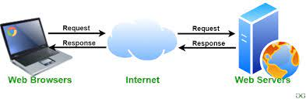

## **Types of Web Servers:**

* XAMPP
* Apache
* WAMPP

Others - AOLserver, NGINX, Lighttpd, Caddy, GlassFish, Boa, etc.

**Apache Webserver**

The Apache HTTP Server Project is an effort to develop and maintain an open-source HTTP server for modern operating systems including UNIX and Windows. The goal of this project is to provide a secure, efficient and extensible server that provides HTTP services in sync with the current HTTP standards.

Performance

Instead of implementing a single architecture, Apache provides a variety of MultiProcessing Modules (MPMs), which allow it to run in either a process-based mode, a hybrid (process and thread) mode, or an event-hybrid mode, in order to better match the demands of each particular infrastructure. Choice of MPM and configuration is therefore important. Where compromises in performance must be made, Apache is designed to reduce latency and increase throughput relative to simply handling more requests, thus ensuring consistent and reliable processing of requests within reasonable time-frames.

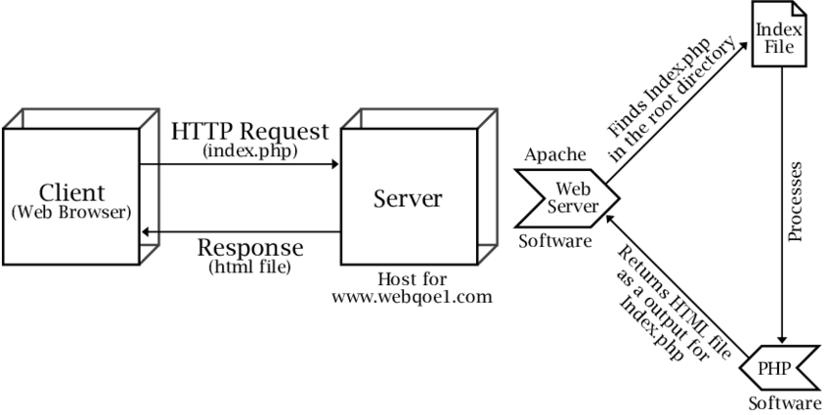

**XAMPP:**

XAMPP is the most popular PHP development environment

XAMPP is a completely free, easy to install Apache distribution containing MariaDB, PHP, and Perl. The XAMPP open source package has been set up to be incredibly easy to install and to use.

XAMPP is an abbreviation for cross-platform, Apache, MySQL, PHP and Perl, and it allows you to build WordPress sites offline, on a local web server on your computer. This simple and lightweight solution works on Windows, Linux, and Mac – hence the “cross-platform” part.

XAMPP is more powerful and resource consuming than WAMP. WAMP provides support for MySQL and PHP. XAMPP also has SSL features while WAMP doesn't. If your applications need to deal with native web apps only, Go for WAMP.

XAMPP helps a local host or server to test its website and clients via computers and laptops before releasing it to the main server. It is a platform that furnishes a suitable environment to test and verify the working of projects based on Apache, Perl, MySQL database, and PHP through the system of the host itself. Among these technologies, Perl is a programming language used for web development, PHP is a backend scripting language, and MariaDB is the most vividly used database developed by MySQL.

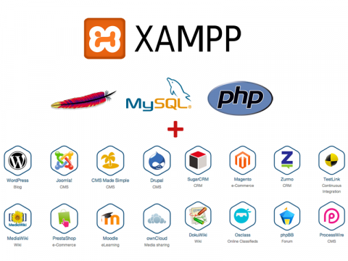

**WAMP**

WAMP is an acronym that stands for Windows, Apache, MySQL, and PHP.\

W” stands for Windows, there’s also LAMP (for Linux) and MAMP (for Mac).

“A” stands for Apache. Apache is the server software that is responsible for serving web pages. When you request a page to be seen by you, Apache grants your request over HTTP and shows you the site.

“M” stands for MySQL. MySQL’s job is to be the database management system for your server. It stores all of the relevant information like your site’s content, user profiles, etc.

“P” stands for PHP. It’s the programming language that was used to write WordPress. It acts like glue for this whole software stack. PHP is running in conjunction with Apache and communicating with MySQL.

|  |  |  |
| --- | --- | --- |
| SR.NO | XAMPP | WAMP |
| 1. | It is a cross-platform software package supported by platforms like Mac OS, Linux, and Windows. | Its local server is only supported by Windows Operating system. |
| 2. | It is easy to download and install but may differ for different platforms. | It is easy to download and install and also light- weighted. |
| 3. | It uses MariaDB, which is an RDBMS for storing and retrieving operations on data. | It uses MySQL, which is an RDBMS for storing and retrieving operations on data. |
| 4. | The programming or scripting languages used for development in XAMPP are Perl and PHP. | The programming or scripting language used for development in WAMP is PHP. |
| 5. | It uses the Apache Web server. | It uses the Apache Web server. |
| 6. | It is more powerful and resource-taking as compared to WAMP. | It is less powerful and resources taking than XAMPP. |
| 7. | It has SSL feature. | It does not have SSL feature. |
| 8. | It is available in a 32-bit system. | It is available in both 64 bit and 32-bit systems. |

**STEPS FOR XAMPP INSTALLATION:**

**Step 1: Download**

XAMPP is a release made available by the non-profit project Apache Friends.

**Step 2: Run .exe file**

Once the software bundle has been downloaded, you can start the installation by double-clicking on the file with the ending .exe.

**Step 3: Deactivate any antivirus software**

Since an active antivirus program can negatively affect the installation process, it’s recommended to temporarily pause any antivirus software until all XAMPP components have successfully been installed.

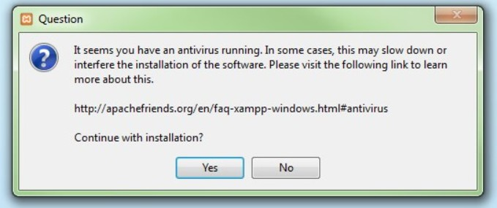

**Step 4: Deactivate UAC**

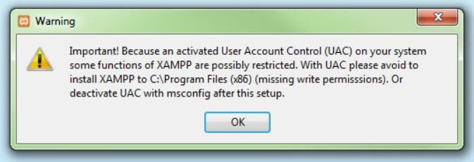User Account Control (UAC) can interfere with the XAMPP installation because it limits writing access to the C: drive, so we recommend you deactivate this too for the duration of the installation process. To find out how to turn off your UAC, head to the Microsoft Windows support pages.

**Step 5: Start the setup wizard**

After opening the .exe file (after deactivating your antivirus program(s) and took note of the User Account Control, the start screen of the XAMPP setup wizard should appear automatically. Click on ‘Next’ to configure the installation settings.

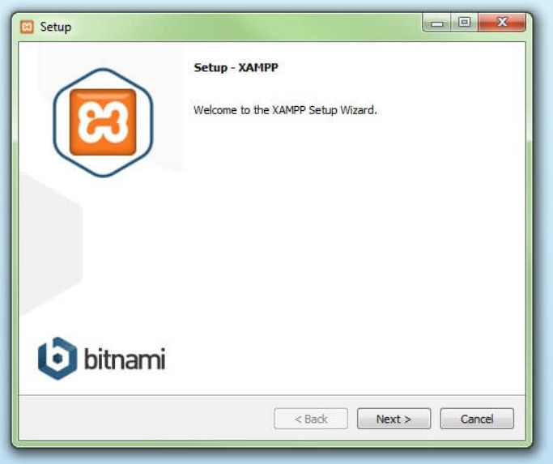

**Step 6: Choose software components**

Under ‘Select Components’, I have the option to exclude individual components of the XAMPP software bundle from the installation. After making the choice, click ‘Next’.

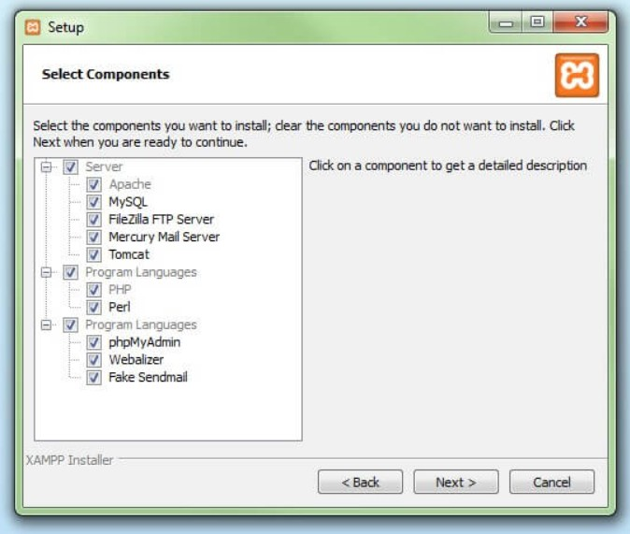

**Step 7: Choose the installation directory**

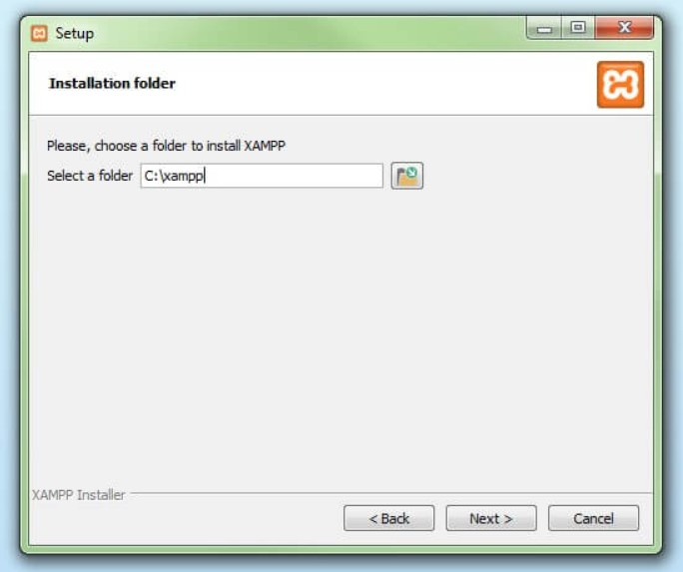In this next step, I have the chance to choose where I'd like the XAMPP software packet to be installed. If you opt for the standard setup, then a folder with the name XAMPP will be created under C:\ . After chosen a location, click ‘Next’.

**Step 8: Start the installation process**

Once all the aforementioned preferences have been decided, click to start the installation. The setup wizard will unpack and install the selected components and save them to the designated directory.

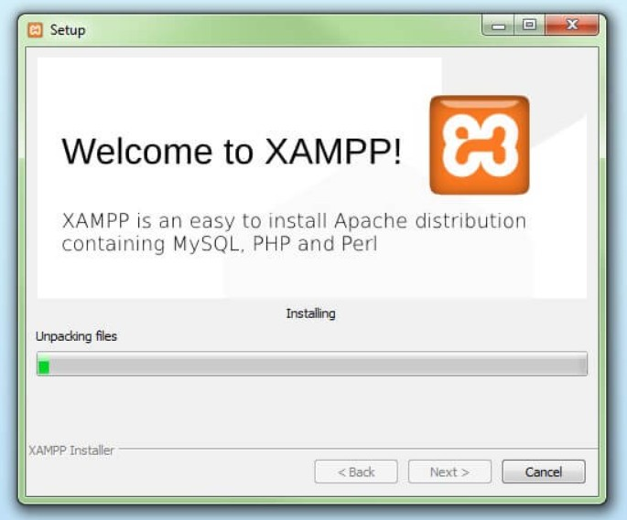

**Step 9: Windows Firewall blocking**

The Firewall may interrupt the installation process to block some components of the XAMPP. Use the corresponding check box to enable communication between the Apache server and your private network or work network.

**Step 10: Complete installation**

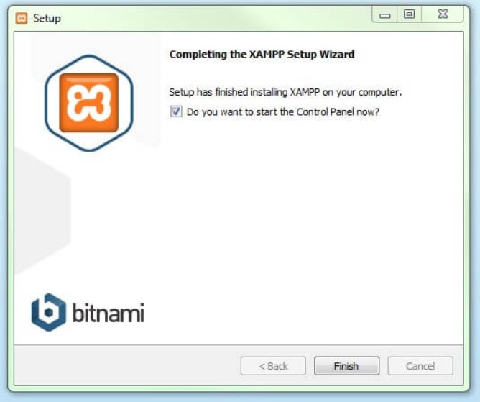Once all the components are unpacked and installed, you can close the setup wizard by clicking on ‘Finish’. Click to tick the corresponding check box and open the XAMPP Control Panel once the installation process is finished.

# **Viva Questions**

### **1. What are the different data types present in C++?**

Ans.

The 4 data types in C++ are given below:

* Primitive Datatype(basic datatype). Example- char, short, int, float, long, double, bool, etc.
* Derived datatype. Example- array, pointer, etc.
* Enumeration. Example- enum
* User-defined data types. Example- structure, class, etc.

### **2. What is the difference between C and C++?**

Ans.

The main difference between C and C++ are provided in the table below:

|  |  |
| --- | --- |
| C | C++ |
| C is a procedure-oriented programming language. | C++ is an object-oriented programming language. |
| C does not support data hiding. | Data is hidden by encapsulation to ensure that data structures and operators are used as intended. |
| C is a subset of C++ | C++ is a superset of C. |
| Function and operator overloading are not supported in C | Function and operator overloading is supported in C++ |
| Namespace features are not present in C | Namespace is used by C++, which avoids name collisions. |
| Functions can not be defined inside structures. | Functions can be defined inside structures. |
| calloc() and malloc() functions are used for memory allocation and free() function is used for memory deallocation. | new operator is used for memory allocation and deletes operator is used for memory deallocation. |

### **3. What are class and object in C++?**

Ans.

A class is a user-defined data type that has data members and member functions. Data members are the data variables and member functions are the functions that are used to perform operations on these variables.

An object is an instance of a class. Since a class is a user-defined data type so an object can also be called a variable of that data type.